**Hello World RESTful Web Service**

**pom.xml**

<?xml version="1.0" encoding="UTF-8"?>

<project xmlns="http://maven.apache.org/POM/4.0.0"

xmlns:xsi="http://www.w3.org/2001/XMLSchema-instance"

xsi:schemaLocation="http://maven.apache.org/POM/4.0.0 https://maven.apache.org/xsd/maven-4.0.0.xsd">

<modelVersion>4.0.0</modelVersion>

<parent>

<groupId>org.springframework.boot</groupId>

<artifactId>spring-boot-starter-parent</artifactId>

<version>3.5.3</version>

<relativePath/> <!-- lookup parent from repository -->

</parent>

<groupId>com.cognizant</groupId>

<artifactId>spring-learn</artifactId>

<version>0.0.1-SNAPSHOT</version>

<packaging>jar</packaging>

<name>spring-learn</name>

<description>Demo project for Spring Boot</description>

<properties>

<java.version>17</java.version>

</properties>

<dependencies>

<dependency>

<groupId>org.springframework.boot</groupId>

<artifactId>spring-boot-starter-web</artifactId>

</dependency>

<dependency>

<groupId>org.springframework.boot</groupId>

<artifactId>spring-boot-devtools</artifactId>

<scope>runtime</scope>

<optional>true</optional>

</dependency>

<dependency>

<groupId>org.springframework.boot</groupId>

<artifactId>spring-boot-starter-test</artifactId>

<scope>test</scope>

</dependency>

</dependencies>

<build>

<plugins>

<plugin>

<groupId>org.springframework.boot</groupId>

<artifactId>spring-boot-maven-plugin</artifactId>

</plugin>

</plugins>

</build>

</project>

**HelloController.java**

package com.cognizant.spring_learn.controller;

import org.slf4j.Logger;

import org.slf4j.LoggerFactory;

import org.springframework.web.bind.annotation.GetMapping;

import org.springframework.web.bind.annotation.RestController;

*@RestController*

public class HelloController {

private static final Logger ***LOGGER*** = LoggerFactory.*getLogger*(HelloController.class);

*@GetMapping*("/hello")

public String sayHello() {

***LOGGER***.info("Start");

***LOGGER***.info("End");

return "Hello World!!";

}

}

**Output:**

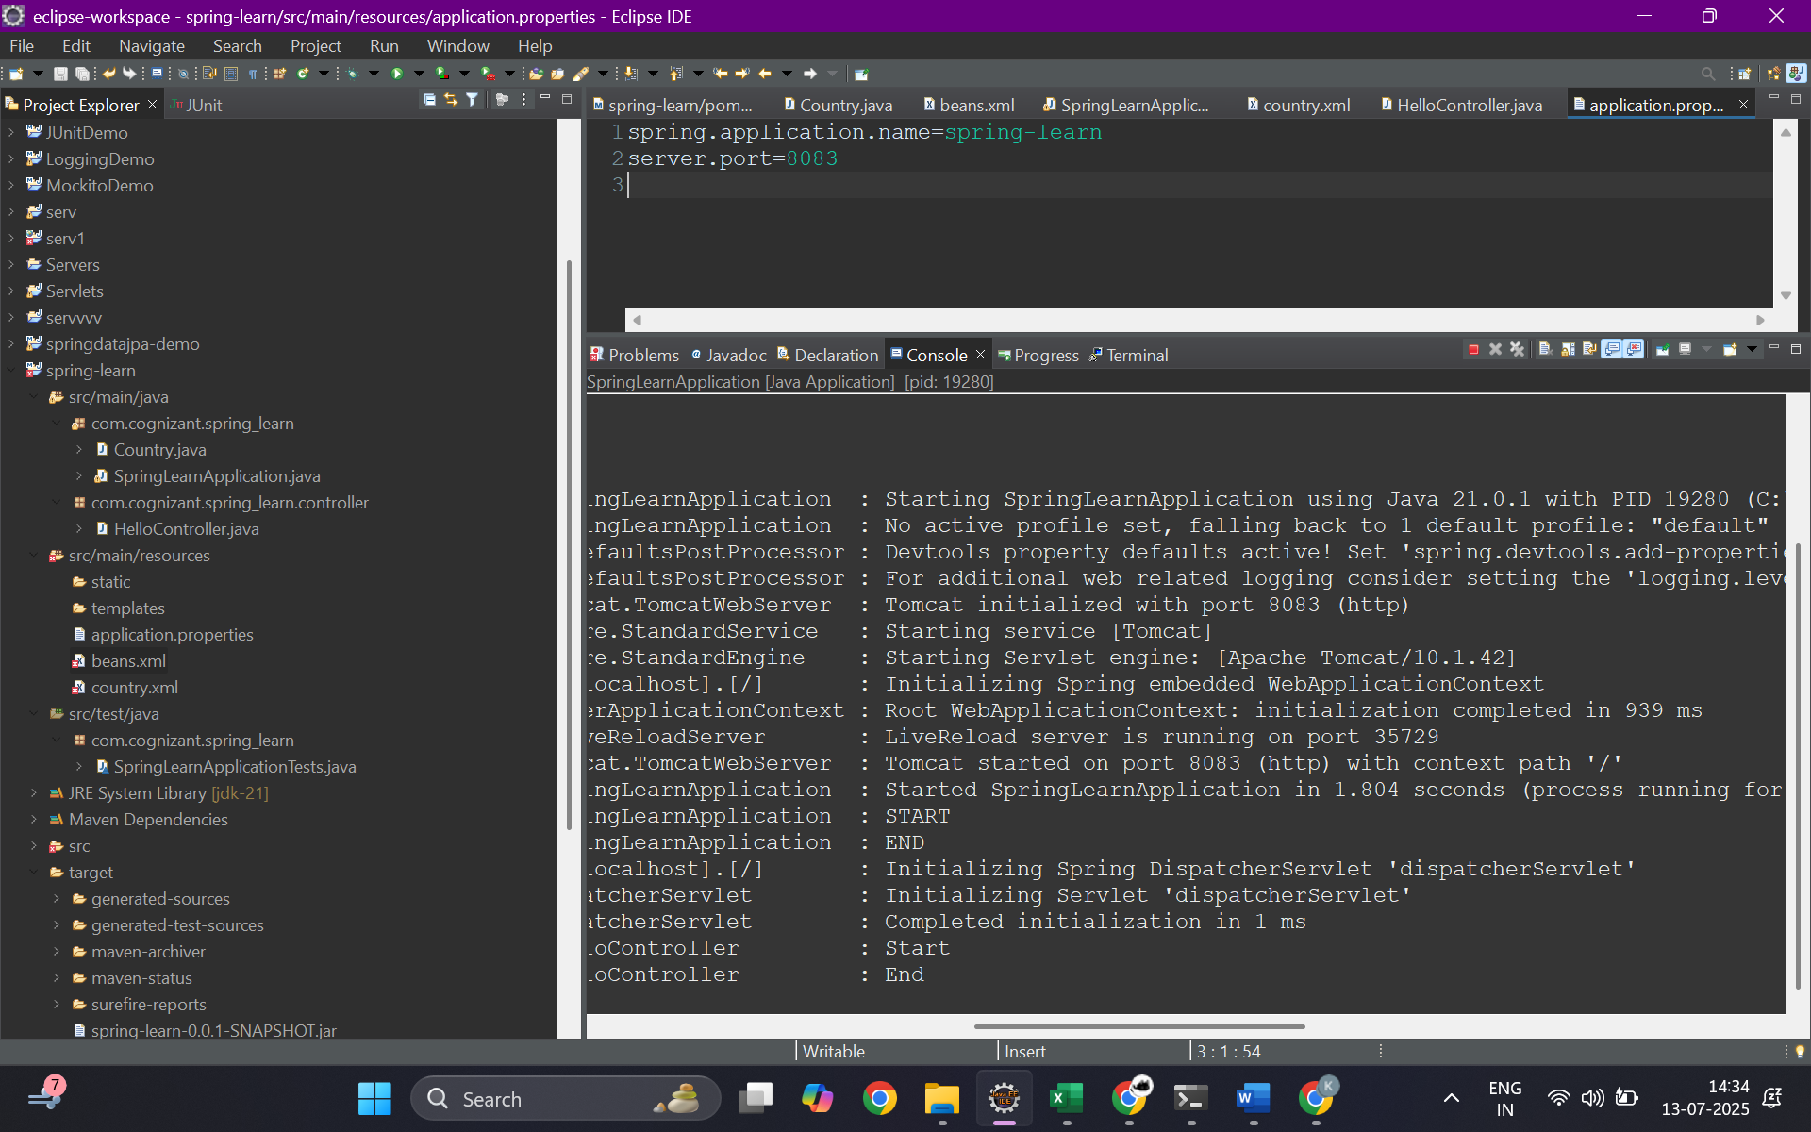

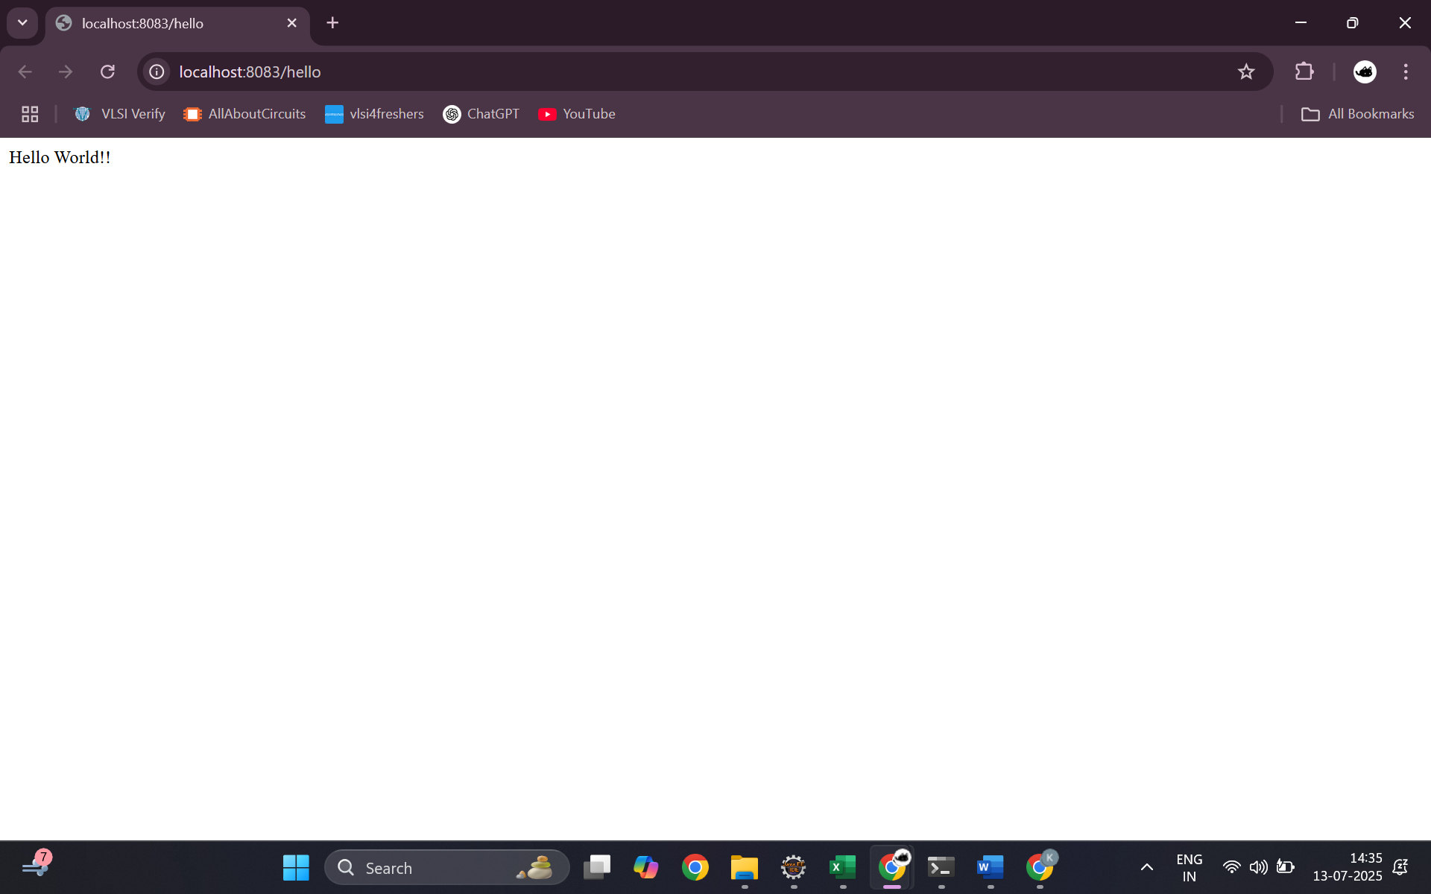

**SME**

This hands-on exercise demonstrated the creation of a basic RESTful web service using the Spring Web framework. A controller class named HelloController was created under the package com.cognizant.spring_learn.controller and was annotated with @RestController, which designates it as a controller for handling REST requests. A method sayHello() was defined and mapped to the HTTP GET method using @GetMapping("/hello"). This method returns a hardcoded string "Hello World!!" as a simple response and includes logging statements to indicate the start and end of method execution. The server was configured to run on port 8083 via the application.properties file. Testing was done through both a browser and Postman using the URL http://localhost:8083/hello, verifying the correct response and inspecting HTTP headers using browser DevTools and Postman’s “Headers” tab. This hands-on helps in understanding the request-response cycle in REST, controller annotations, and endpoint testing in Spring Boot.